Project Management

Unit 9 Assigment

SamUel Chambers

2020

# Table of Contents

Table of Contents 1

Client Brief 2

Project Idea Generation 2

Research 2

Possible Solutions 2

Solution One: Access Database with Access User Interface 3

Solution Two: VB Form with an Access database Connection 4

Preferred Solution 5

Designs 5

User-Interface Designs 5

Home Screen 6

Student Profile Screen 6

Student Profile Editor Screen 7

Student Attendance Screen 7

Processes Required 8

Cost Outline 8

Performance Parameters 9

Feasibility Report 9

Technical Assessment 9

Economic Assessment 9

Legal Requirements 9

Usability Assessment 10

Success Criteria / Project Requirements 10

Project Phasing 10

Project scope 10

Requirements 10

Student Profiles 10

Student No. 11

Lessons 11

Attendance Status 11

Comments (Behaviour, illness and other general comments) 11

Project Planning / Time plan 12

Change Requests from Client 12

Risks / Issues and Resolutions 14

Section D 14

Evaluation & Conclusion 14

Final Thoughts 14

Lessons learned During this project 14

# Client Brief

I have been approached by a new customer, offering the job of helping solve possible IT solutions. A local school is having difficulties tracking student attendance, and has asked me to create a student register form (for tracking attendance) as well as class registers, handling the following data as a minimum:

* Student Profiles (Student information)
* Student No. (Unique student identification)
* Program (Class the student is in)
* Status (Attending, Sick or absent)
* Comments (Behaviour, illness and other general comments)

The program must take inputs from the teachers for example a combo box list of inputs A-Absent P-Present and S-Sick. If the student needs to be contacted, then the teacher can bring up their profile to get contact information.

# Project Idea Generation

A local school is having trouble tracking student attendance and need a viable solution to this. They need an application to receive inputs from the user (teacher) and then store this according to the appropriate student. This application needs to be of a professional standard.

## Research

Every school, college and university need a database of their students. This usually contains, student names, ID, email, photo ID, date of birth and subjects studying. An online database is convenient, can’t be physically lost unlike storing the records physically in a filing cabinet. An online database can also improve time spent searching for an individual record as a quick and easy search will bring records that meet that criteria.

## Possible Solutions

I researched two possible solutions giving a detailed overview of the benefits and issues with both solutions. The solutions I chose were based on my own knowledge and simply which solution would match the client’s requirements the most.

### Solution One: Access Database with Access User Interface

In this solution I would create an MS access database that will handle the data stored by the school containing student information and class registers, this will be the back end of the software. I will then design a user-interface for the front end, so the information can be entered and or accessed without looking directly at the database. This would allow me to have the information stored in an access file while also having a way for the information to be retrieved and accessed using a user-interface. This will allow me to design the user-interface with more control. This method entails risks. Using an access database data can be mistyped or entered incorrectly, creating a problem. Due to the lack of experience in this field this method would not be se suited for the solution required

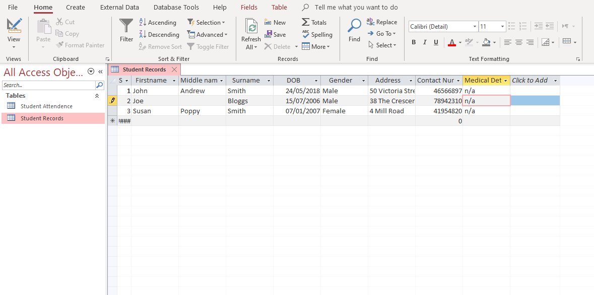

Here is an example of a Database created for the use in a school/ educational environment. This will handle the storage of the information. The data can be entered two ways, one by entering it directly into the database file and the other using a user-interface design, giving the user a more graphical interface. For example, like the one shown below.

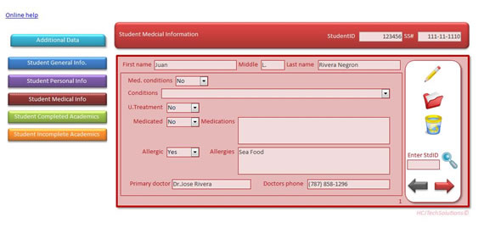

### Solution Two: VB Form with an Access database Connection

This solution would use a Visual basic windows form for the front end, allowing me to create a user interface. I would then create an access database connection to allow me to integrate a database integration. This method will provide ease of use as it will be simple to use. Using this method, I would include multiple forms containing the necessary controls to navigate the records effectively. I will also include a way to access and view the student profiles, while having another button to allow the user to edit a selected profile. There will also be another button on the home screen allowing the user to access the class register while also including the ability to set a relevant attendance status to each student. There are some identified risks with this method, such as mistyped data or incorrect format. This can be mitigated by adding a format, for example adding letters in the date of birth section. Another issue I found was if there becomes an issue with the database connection between the application and MS Access the program will not work then a trained IT technician will be required to fix it. This can be mitigated by adding enough file permissions so only authorised personal can tamper with it.

Here is a simple flowchart design showing how the user will select a window to view. This flowchart shows that the application will wait for the users input, once received it will act accordingly.

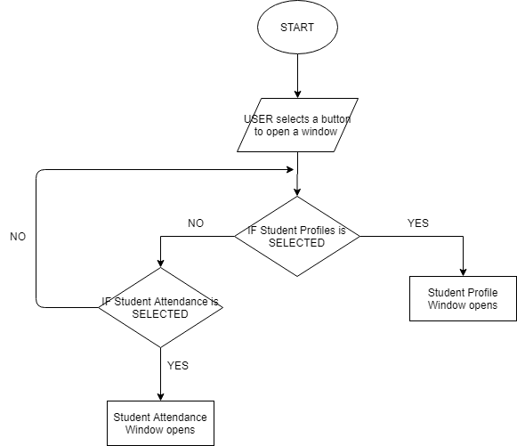

From this solution I will use an access database to handle the information while having

### Preferred Solution

The solution I have chosen to use is the Visual Basic Windows form with a database connection to MS Access. I chose this method because I have more experience with windows forms as user-interface compared to using MS Access for a user-interface which I have no experience this method would provide a better solution compared to the other method. So, I chose to use VB windows form on the front end and a database connection on the back end. This would allow me to have more customizability to design the application the way I deemed appropriate for example I can place buttons, controls and data grid views where I like. This method will also allow me to add data validation checks for each data entry point, reducing the risk of invalid data or mistyped data.

# Designs

The following designs are based on the solution I have chosen to solve the client’s brief.

## User-Interface Designs

### Home Screen

This Screen will include the home screen giving options in the form of buttons to access the Student profiles, this will take you to another screen containing details of students. The other button will then take you to the class register form.

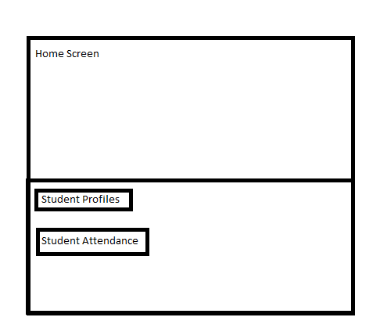

### Student Profile Screen

The next UI design is the Student profiles screen. This will show you a data grid view based on the access database connection, this will show details including student, Names (first, middle and last), Specific identification number, Contact numbers, emails, address and other important information. At the bottom of the screen it will be divided into database controls, the controls will include next and previous record, Save datasheet ,close datasheet there are also two more buttons one with the name home this will take you back to the home screen and the other with the name edit contents will take you to the next screen. Finally, a box containing a textbox to search the database for specific criteria this will retrieve only matching criteria.

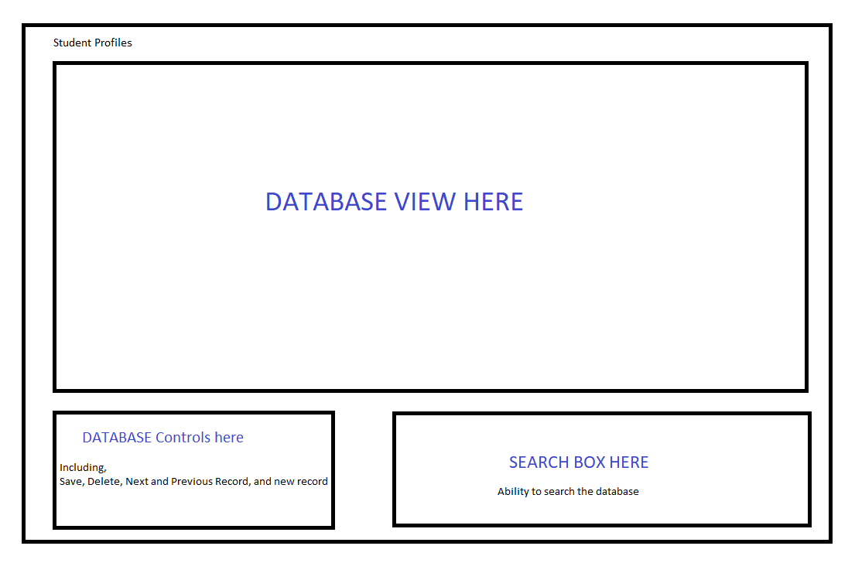

### Student Profile Editor Screen

This screen can be accessed by using the button labelled edit contents. This screen will be like the student profile screen, in the sense of having database controls, there will be two additional buttons that will allow the user to create a new record or delete the selected record, and the data grid view with one difference. There will be text boxes that will allow the user to enter details for a new record or edit an existing record.

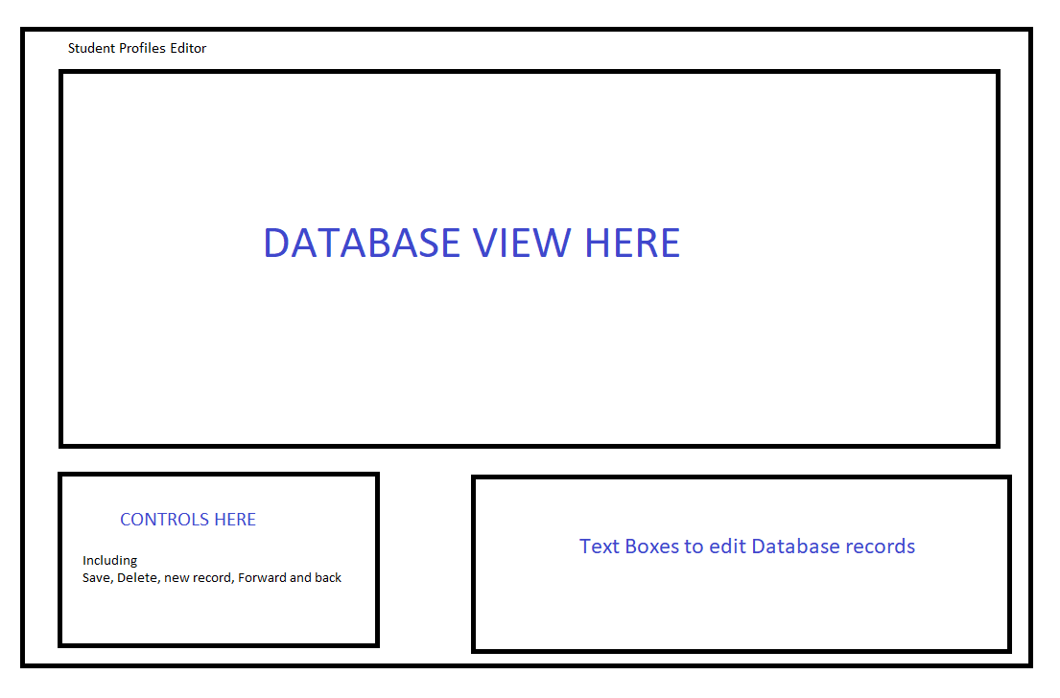

### Student Attendance Screen

This screen will be accessed by clicking the button on the home screen labelled Student attendance. This screen will allow the user to take the register giving the user the option to mark the specified student as present, absent or sick. This screen will contain the same controls as the student profile screen.

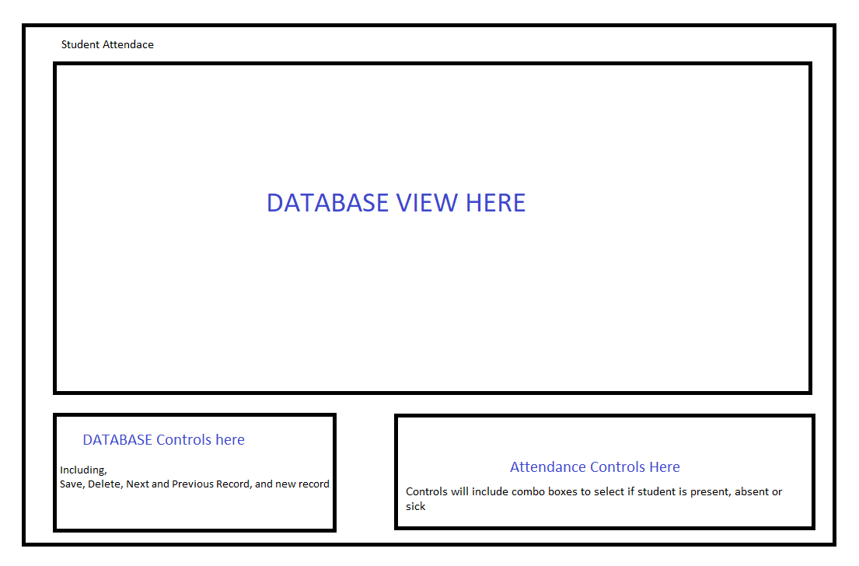

## Processes Required

There will be several key processes required, in order to meet the client’s requirements, bellow I have outlined all the essential processes critical for this solution to succeed.

* There must be an option to view student profiles or view class registers, this will be done using buttons that link the appropriate form (Screen containing the contents if the button). This will give the user the option to select the window they want to view.
* There must also be a home button taking the user back to the home screen. This will give the user the option to change window view, allowing them to change between looking at the class register to student profiles.
* Student profile, form. There must be controls allowing the user to navigate through the records. This will give the user the option to select and view a specific record. There will also be the option to save and close the datasheet this will save any changes made to the database and then close it.
* Student register, form. There must be controls allowing the user to navigate through the records within the class register. This will give the user the option to select and view a specific record in the register. There will also be the option to save and close the datasheet this will save any changes made to the database and then close it.
* Student profile, form. There must be the option to edit the contents of the selected record this will give the user the ability to update or delete information from that record. This will be done using a new form called the Student Profile editor accessed via a button on the Student Profile form. This will make viewing the student profiles easier as there will not be the issue of accidentally changing data.
* Student Profile, form. There must be the option to search for a specific piece of data for example a first name, last name or middle name. This will allow the user to search for a record quickly to access the information.
* Student Attendance Class register, form. There must be the option to allow the user to update a student’s attendance status. This will let the user select if the student is present, absent or sick.
* There must be data validity checks at each input received from the user. This will prevent the issue of having invalid data causing issues later.

## Cost Outline

|  |  |  |  |
| --- | --- | --- | --- |
| DESCRIPTION | HOURS | RATE | AMOUNT |
| **Solutions Evaluation,** Including evaluation of project risks and mitigation. | 2 hours 30 mins | £45/hr. | £112.5 |
|  | | | |
| **Project Designs**, Including graphical sketches/ diagrams, outline of required process, high level flowcharts, initial technical parameters | 3 hours | £35/hr. | £105 |
|  | | | |
| **Feasibility Report,** including technical assessment, legal assessment, operational assessment, scheduling assessment, security assessment and usability assessment | - | - | - |
|  | | | |
| **Project requirements,** success criteria | - | - | - |
|  | | | |
| **Software Development,** full development of software applications, with full right of use,   1. monitoring the project, monitoring log, proof of alteration 2. Project Phasing 3. Risk and issue resolution | - | £40/hr. | - |
|  |  |  |  |
| **Project closure,** solution evaluation | - | £35/hr. | - |
|  | TOTAL | |  |

## Performance Parameters

The solution I create needs to be able to run on a range of systems especially low-end systems. I need to make the application light allowing all capabilities of systems to run it. This will ensure there will be no issues from the systems not being able to run my application. Providing a broad range of capabilities.

# Feasibility Report

An outline of the resources and skills required to produce the IT solution. Ensuring it is economically viable. A student information tracker application created for a local school. The solution I chose to solve the client’s issues, will entail two main methods such as Visual Basic programming and database connection.

## Technical Assessment

There is a range of technical resources that I will use include MS Docs this will be essential to the completion of this solution. This will help me overcome any issues I come across. It will also help me optimise the solution to provide the absolute best product I can.

## Economic Assessment

The cost of this solution is expected to cost the client around one thousand pounds. This price I extremely viable due to the reusability of the solution being issued. The solution will be in use for many years allowing the client to get full use of the product, providing great returns.

## Legal Requirements

Due to the nature and deployment location this product has certain legal requirements that must be abided for this product to be viable. This solution must comply with the data protection act, meaning all data stored by the organisation must be protected from unauthorised users; because the information being stored is personal, it must be secured under the general data protection regulation as well. This mean the stored data must not be taken outside of the European Union where data protection laws may not be enough.

## Usability Assessment

The solution I have planned to create is effective at solving the client’s issues. My solution enables the users (teachers) to effectively complete their role in the workplace, it allows them to perform their safeguarding duty by giving them the relevant information needed to ensure the safety of their pupils.

## Success Criteria / Project Requirements

The solution should meet these set criteria in order to be successful. The following criteria should be met at a minimum.

* View student profiles.
* Edit student profiles.
* Select student’s attendance status.
* View essential information about students (medical, learning disabilities).
* Apply comments about a specific student.

# Project Phasing

For this project I have chosen the waterfall methodology. As this project is small it allows me to oversee all stages without being overwhelmed with the workload. This method also me to follow a linear process to the methodology. This method is most appropriate as it allows me focus on all the core aspects, like documentation, analysis and finally development of the solution.

## Project scope

The solution in question must abide to criteria set by the client. For example, the solution must be finished, delivered and implemented by the deadline. The solution must be professional as the environment it will be implemented in, is in a school this will mean, vulnerable children will be around the final solution. The end solution must also comply to other essential criteria the client has provided. I have decided to complete the project using the waterfall methodology. The steps involved in the waterfall method allow me the take a linear approach to solve the client’s issues. This method ensures I do not miss essential steps in the development process. The first step to this process was to define the requirements that would be necessary to the success.

## Requirements

A local school is having difficulties tracking student attendance, and has asked me to create a student register form (for tracking attendance) as well as class registers, handling the following data as a minimum:

### Student Profiles

To achieve this criterion set by the client the solution must be able handle important information about every student in the school. While actively being able to retrieve and view and or edit this information. Teachers need to be able to look up specific information about certain pupils or groups of pupils that meet a certain requirement. To do this there must be certain fields in the table holding the information there should be fields holding the following data as a minimum, First and last name, date of birth, student ID.

### Student No.

There are two definitions connected to this criterion. Firstly, a unique student identification number, this will ensure that students with the same first or last name or both will not be mistakenly identified. Secondly, a student emergency contact number. This can be used in case of emergency that the student can be contacted to ensure their safety. This number will be generated when a student is entered into the database.

### Lessons

This criterion will handle the lesson a student is taking. This will allow a teacher to

### Attendance Status

### Comments (Behaviour, illness and other general comments)

The program must take inputs from the teachers for example a combo box list of inputs A-Absent P-Present and S-Sick. If the student needs to be contacted, then the teacher can bring up their profile to get contact information.

## Project Planning / Time plan

## Change Requests from Client

From meetings with the client, the amendments stated bellow

1. Add the option on the register’s GUI form: Does the student Have disability: Y? or N? Added as a combo box inside its data or list entry on the windows register form. Added the option to select a disability.

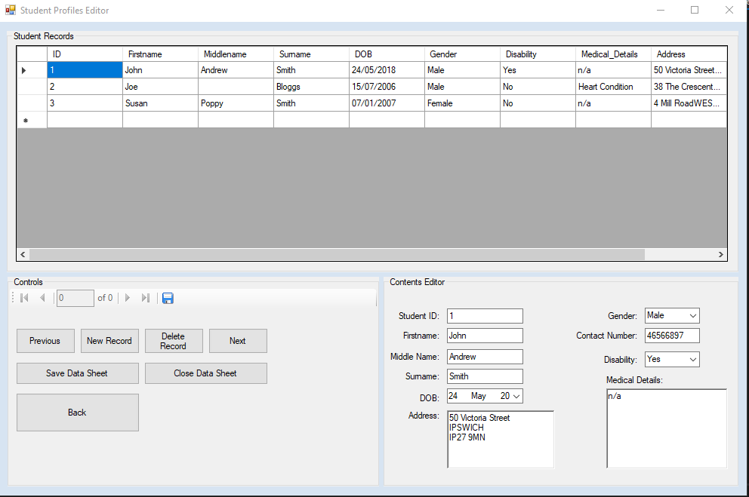

1. Do change the font size of the title displays at the beginning of the options page to size 16 point. Changed the font size on the home screen

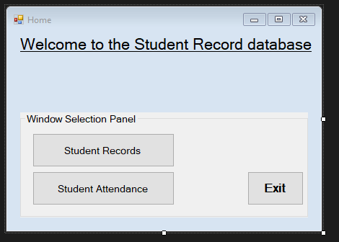

## Risks / Issues and Resolutions

There were several issues I encounter when developing this project. Some being harder than others to solve. Issues I encountered ranged from not being able to create a navigation button, to creating a button to navigate forms.

# Section D

## Evaluation & Conclusion

During the project closure there will be server key points made/ outlined. These will include lessons learned, behaviours applied during the project, problem solving and overall evaluation. I will outline what was successful about the project as well as what could be improved.

### Final Thoughts

The solution I created was very successful at meeting the client’s needs. The planning I completed was very thought out, this allowed me to have an extremely clear understanding of the steps ahead of me, resulting in a proactive approach to this solution overall making this project a lot easier. When choosing the option, I’m certain I made the correct decision as I believe the other option, which was the development of the website, would be significantly harder given the lack of knowledge in that field and consequently would have made the process as a whole a lot more difficult. Finally, although there were some problems, I encountered with the solution, it does not take away from the point of the solution being completely functional and in working state.

### Lessons learned During this project

There were several lessons learned over the course of this project. One being documentation during the project planning is important. I learnt the importance of documenting the plans and not just making it up as you go. Another lesson I learnt was to appropriately name the forms when you create them not once you have added all the functionality to it, as this almost certainly results in problems with the name, with my solution this resulted in lots of issues for me, I almost had to restart my solution when I encountered this issue, luckily I had a backup of the solution and was able to restore using my backup, not much was lost after the backup and no naming issues.